**Embedded Systems Lab Report**

Introduction:

The task was to build a seismometer using the STM32 microcontroller. The vibrations of the an earthquake were to be mimicked using a potentiometer. It is to let out a warning and display the magnitude of the earthquake, and the displacement.

Components:

|  |  |  |  |
| --- | --- | --- | --- |
| https://scontent-lht6-1.xx.fbcdn.net/v/t34.0-12/26754865_1524784160974505_213686775_n.jpg?oh=fd4b249bac26cc070b642c0ed364e659&oe=5A56A821 | https://scontent-lht6-1.xx.fbcdn.net/v/t34.0-12/26753815_1524784130974508_1942274882_n.jpg?oh=713aa22ec523a7699da068567c981890&oe=5A559E7A | https://scontent-lht6-1.xx.fbcdn.net/v/t34.0-12/26694545_1524784170974504_855899425_n.jpg?oh=9f3498344b5cd05c31cd5bf766ebf0eb&oe=5A55A12E | https://scontent-lht6-1.xx.fbcdn.net/v/t34.0-12/26754390_1524784157641172_1245919490_n.jpg?oh=10aa7e003c48f09f5dc81eb12de98cfe&oe=5A557D95 |
| Jump Wire | Breadboard | Potentiometre | STM32F407G |

Circuit:

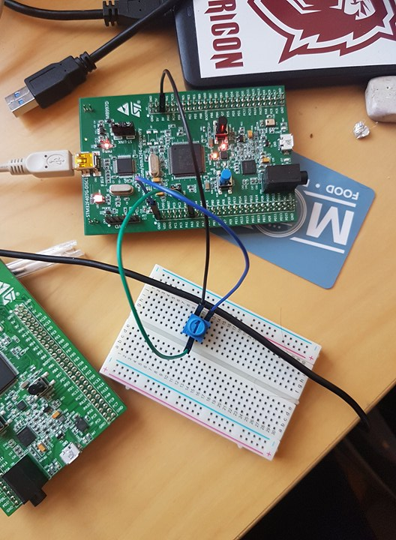

Coding:

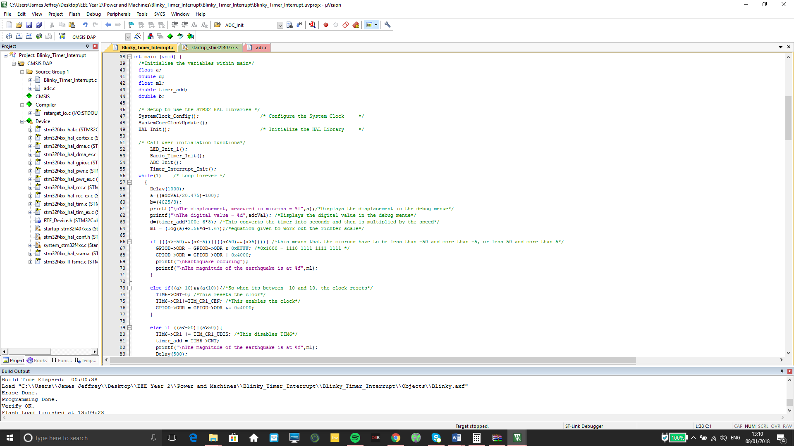The seismometer:

In this section of the code, the variables are declared, the main calculation of displacement is made, and warning signals are initiated. How distance between the S and P waves, is defined as the displacement. To find the displacement, the analogue to digital must be obtained, this is pinned out from PA3. Inputting the digital value into an equation, a value of between -100 and 100:

$$Displacement=\frac{adcVal}{20.475}-100$$

To find the magnitude, the distance between the S and P waves needs to be calculated. This is done by using the timer interrupt in seconds and multiplying it by 8 kilo metres a second. The equation is as follows:

$$Distance=Timer*{10}^{-6}*8$$

The distance and the displacement is then inputted into the following equation:

$$ML=\log\left(displacement\right)+2.56\log\left(Distance\right)-1.67$$

Everything that is calculated and measured is displayed.

It is then coded that when:

$$- 5 <Displacement > -50$$

And

$$5>Displacement< 50$$

5 and -5 were used due to fluctuation within the potentiometer.

A red LED is then turned on and warning printed in the debug console. This will keep repeating until the earthquake is relieved. This is when the clock will restart and become enabled again. There is still constant monitoring of the Magnitude and Displacement.

More than -50 and 50, the timer is disabled and the magnitude is displayed.

Voltage:

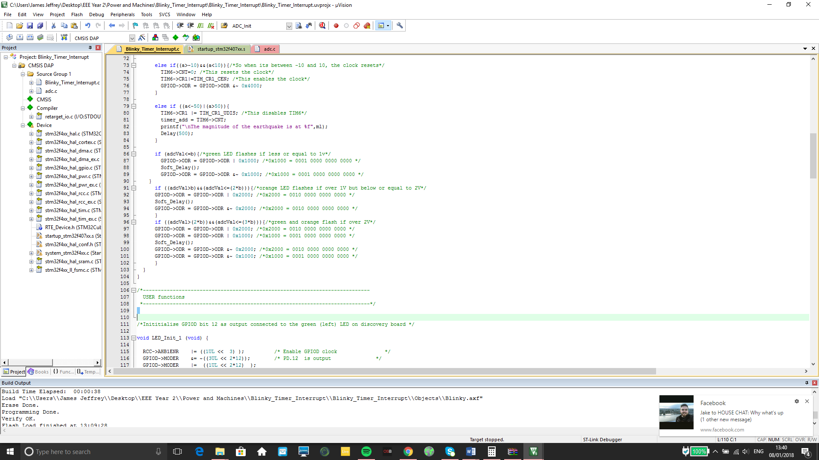

This piece of code detects when the voltage is:

$$adcVal≤1V$$

$$adcVal>1V and adcVal<2V$$

$$adcVal≥2V$$

This is done by finding the highest digital value recorded which is 4095, and is then divided by the max voltage, which is 3V. When the voltage is less than or equal to 1, then the green LED flashes. When the voltage is more than 1 but less than or equal to 2, then the orange LED flashes. When the voltage is greater than 2, then both the green and orange LEDs flash.

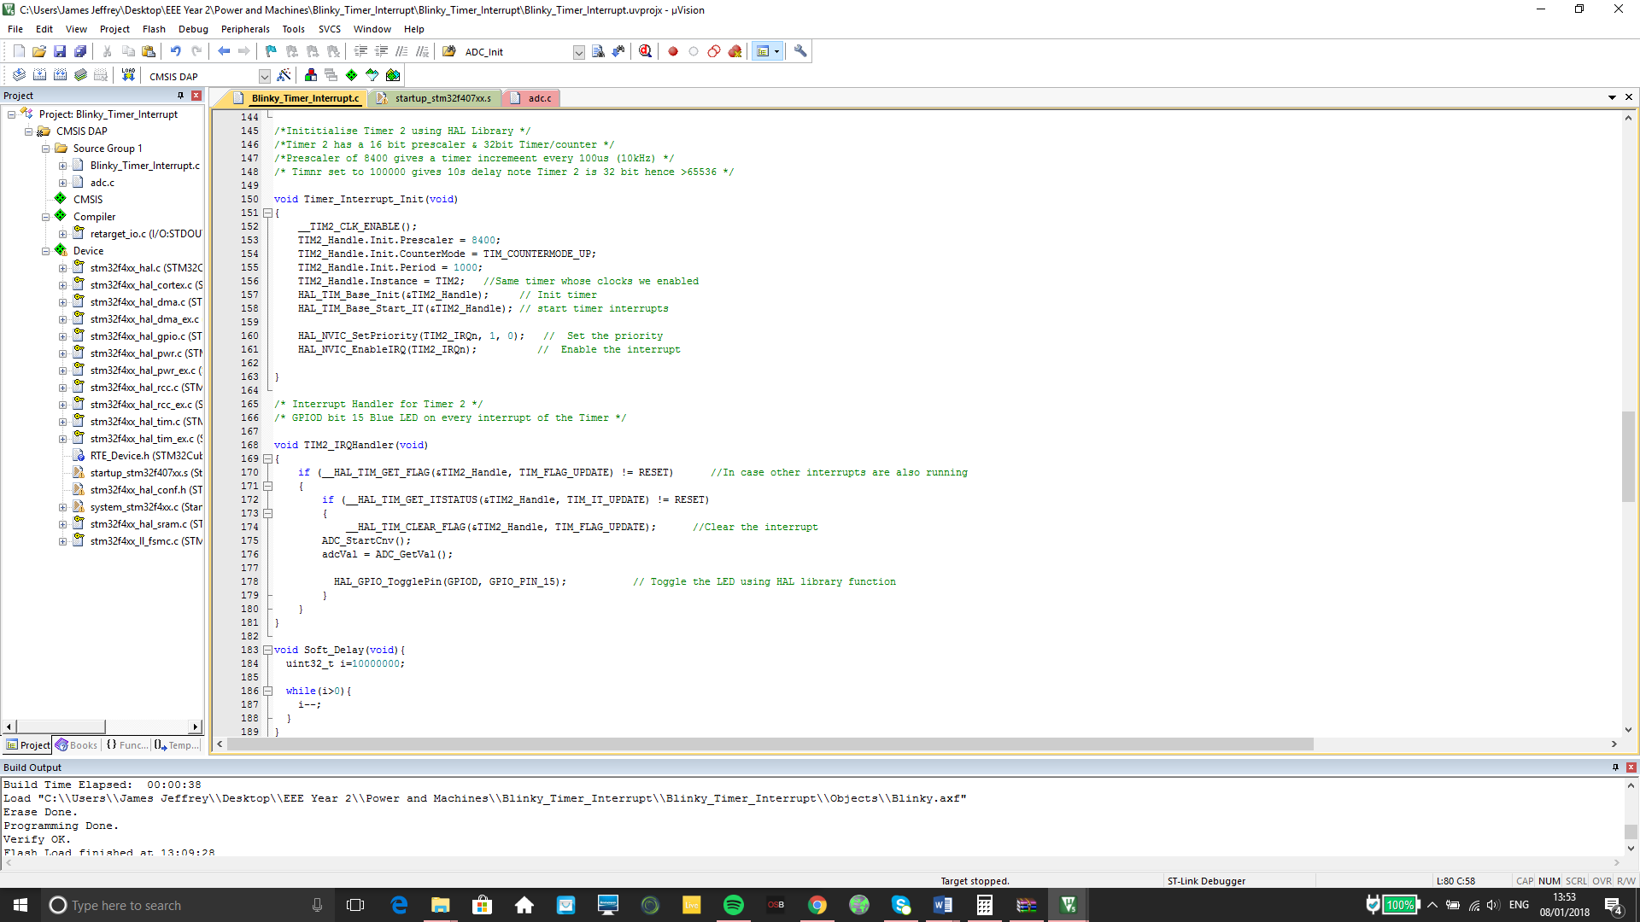Interrupt:

The timer interrupt and scaler were used to start the Analogue to Digital converter and to store the digital value obtained into the variable adcVal.

Conclusion:

During this project, many troubles occurred due to not importing the correct libraries, this took up a lot of time which could have been used to better the code. The code could be more efficient, this may be by using commands that more research is needed, to be used. Additional details could have been added to the code, such as using an LCD screen, instead of using the debug screen to see the values. The voltages were displayed using the onboard LEDs. The use of external LEDs would mean that more parameters could be shown.